Fundamentals Of Data Structure And Algorithms
Github Link:
https://github.com/rudraaaajoshi/FDSA_BATCH_A/tree/main/Practical-1
Practical-1.1
Difficulty:
The main difficulty was understanding how the elements of the array should change their positions after every hour. I had to carefully understand that the leftmost element is moved to the rightmost position after each rotation.
Error:
At first, I performed the rotation directly using the given number of hours. This could take a very long time when the value of h was very large. I also had to make sure that the positions of all elements were updated correctly.
Solution:
I used the modulo (%) operator to find the actual number of rotations required. Since rotating an array by its complete size brings it back to the original order, h % n gives the required rotations. This also avoids unnecessary operations.
Outcome:
I successfully implemented the array rotation operation and obtained the correct final display order. I also learned that modulo can be used to make an array operation faster when the number of rotations is very large.
Code(Github) Link:
https://github.com/rudraaaajoshi/FDSA_BATCH_A/blob/main/Practical-1/pr%201.1.c
Output:
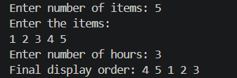
Key Questions:
Problem -1
The display order repeats itself after a certain number of hours regardless of how large h gets. Without trying any specific example, explain why this repetition is inevitable and what determines when it first repeats.
Answer:
The repetition is inevitable because a display has a fixed number of possible states. After a certain number of hours, the display must return to a state that it has already shown. The first repetition depends on the cycle of the display system. For example, if the display represents a 12-hour clock, the same display repeats every 12 hours because there are only 12 different hour positions. So, no matter how large h becomes, the display can be reduced to its repeating cycle using the modulo (%) operation. The repetition is inevitable because the display has a finite number of possible states. The first repetition occurs after completing one full cycle, which is determined by the number of states in that cycle

Practical 1.2
Difficulty:
The main difficulty was identifying which book IDs occurred more than once in the borrowing record. I also had to make sure that IDs appearing many times were still displayed only once in the final output.
Error:
Initially, when comparing every ID with the other IDs, the same duplicate ID could be found and printed multiple times. This would make the output repetitive and incorrect.
Solution:
I used nested loops to compare each book ID with the remaining IDs in the array. I also used a check to make sure that an ID which had already been processed was not printed again. If its count was greater than one, it was displayed as a duplicate.
Outcome:
I successfully found all the book IDs that were borrowed more than once and displayed each duplicate only once. This helped me understand how nested loops can be used to compare elements and find repeated values.
Code(Github) Link:
https://github.com/rudraaaajoshi/FDSA_BATCH_A/blob/main/Practical-1/pr%201.2.c

Output:
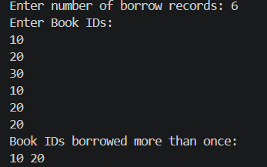

Key Questions:
Problem-2
If the same book ID appears three times in the log, should it appear once or three times in your output? Does your solution handle this correctly, and how would you verify it?
Answer:
If the same book ID appears three times, the answer depends on what the problem asks. If the problem is asking for distinct/unique book IDs, then it should appear only once. If the problem asks for unique book IDs, an ID appearing three times should appear only once. I would verify this by testing the program with duplicate IDs and checking the output.

Practical 1.3
Difficulty:
The main difficulty was taking the complete sentence as input instead of taking only one word. After getting the sentence, I also needed to separate the words and compare their lengths one by one.
Error:
Initially, I faced difficulty while handling spaces between words and making sure that the length of each word was calculated correctly. There was also a possibility of selecting the wrong word if the comparison was not done properly.
Solution:
I used fgets() to read the complete sentence including spaces. Then I processed the sentence word by word and compared their lengths. Whenever a word with a greater length was found, I stored it as the current longest word.
Outcome:
I successfully displayed the longest word along with the number of letters it contains. Through this practical, I learned how to take a complete sentence as input and process individual words using string operations.
Code(Github) Link:
https://github.com/rudraaaajoshi/FDSA_BATCH_A/blob/main/Practical-1/pr%201.3.c

Output:
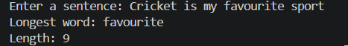

Key Questions:
Problem-3 The editor later decides that punctuation attached to a word (e.g. “hello,” or “great!”) should not count toward its length. How would this change your solution, and at which step would you handle it?
Answer:
I would remove punctuation from the word before calculating its length. This change would be handled during the input/preprocessing step, before finding the word length. For example, hello, would be treated as hello, so its length would be 5.

